d, MA 01103
LLumin Disconnected Mobile App User Guide
(413) 216-4700

Email: Jack@llumin.com
https://llumin.com/
Contact LLumin






This Photo by Unknown Author is licensed under CC BY-SA
293 Bridge Street
Springfield, MA 01103
(413) 216-4700
https://llumin.com

Contents
INTRODUCTION 4
Prerequisites 4
LLumin Core Application 4
Download the LLumin mobile application 4
Configuration, Resetting, Syncing, and Login 5
Configuration 5
Resetting 5
When to reset 6
Syncing 6
Login 7
Home Page 8
Home Page Lists 9
My Work Requests 9
All Work Requests 10
My Work Orders 11
My Craft’s Work Orders 12
All Work Orders 13
Down Assets 14
All Assets 15
Search Screen 16
“More” Screen 17
Requests 17
Create 17
Edit 18
Work Orders 18
Create 18
Edit 19
Complete 20
Labor Time 21
Existing Labor Time 21
Adding new Labor Time 22
Copying Labor Time 25
Assets 26
Create 26
Edit 28

INTRODUCTION
This User Guide will cover the LLumin disconnected mobile application. The mobile application is subject to change as versions are deployed; the functionality and screens outlined below may also change.
Please note that disconnected mobile app version 2.1 includes support for barcode scanning using the integrated camera on the mobile device running the mobile app.

Prerequisites

LLumin Core Application
- For the LLumin disconnected mobile to sync properly, the core LLumin Application must be running at least Version 21.9 (September 2021).
- The version number can be found by clicking the “I” icon in the upper right and clicking “About LLumin”.
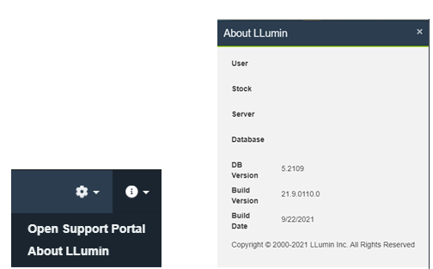

- The System Configuration to enable the Mobile module must be enabled.
  - Please reach out to LLumin Support at support@llumin.zendesk.com or 413-233-5434 to enable.
- A user account will also need to be set up for the user signing into the mobile application.

Download the LLumin mobile application
- The mobile app can be downloaded from the Google Play Store or Apple Store depending on your mobile device.
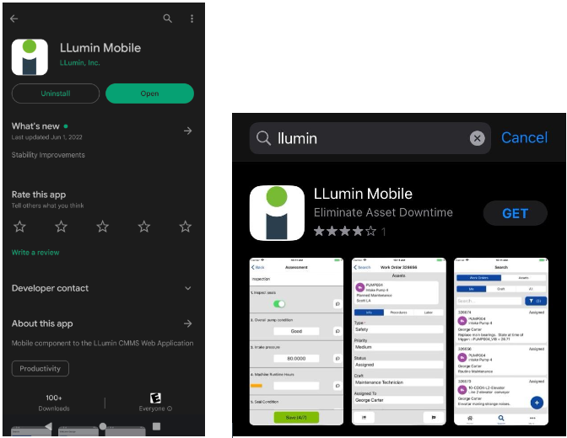

Configuration, Resetting, Syncing, and Login

Configuration
- Please refer to the following article with instructions on how to configure the mobile app: https://llumin.zendesk.com/hc/en-us/articles/4407342421139

Resetting
- How to reset
- You can reset the data on the mobile device by clicking on the gear on the login screen to open the Settings screen and clicking the trash can icon as shown in the example below.
- Please note that resetting the data on the mobile device will clear all un-synced updates on the mobile device.
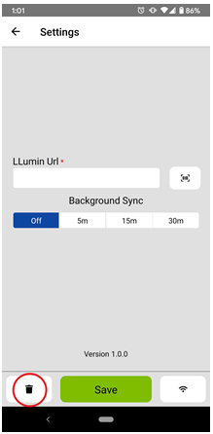

When to reset
- Resetting the data on the mobile device is typically only necessary if the device was used with the previous version of the mobile application and data was synced.
- There may be specific circumstances where the LLumin Support team will instruct a user to reset the data on the mobile device.

Syncing
- To initialize a sync, you must have correctly entered the LLumin URL and click the double arrows on the login screen
- Please refer to the section on Configuration for more details on entering the LLumin URL.
- Once the sync button is pressed, under the blue Login button, there will be a message indicating a download is in progress with a percentage. That message will disappear once the sync is completed successfully.
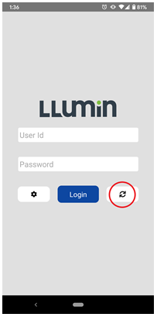

Login
- Once the mobile device has been successfully synced, you can then sign in using the same credentials used with the core LLumin application.
- If the sync was not successful or has never been performed on the mobile device, the following message will be shown.
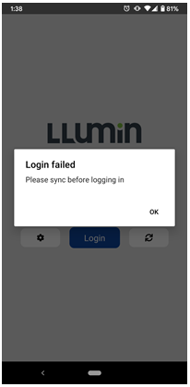

Home Page

- Following a successful login to the mobile app, the user will be presented with a number of home page lists and menu options. Please note the lists are subject to change in future releases and some lists may not be available depending on your specific LLumin environment’s configuration.
- The below is a sample of the Home Page
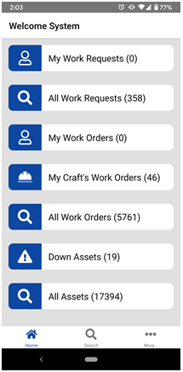

Home Page Lists

My Work Requests
- This list will open the search menu and prefill the object type to “Requests” and filter for the user’s requests.
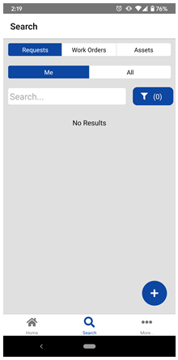

All Work Requests
- This list will open the search menu and prefill the object type to “Requests” and filter for all requests.
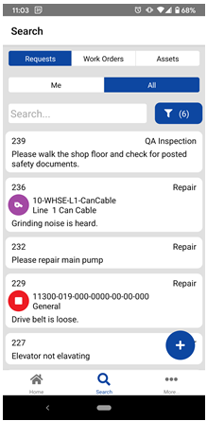

My Work Orders
- This list will open the search menu and prefill the object type to “Work Orders” and filter for the user’s Work Orders.
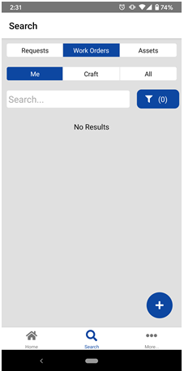

My Craft’s Work Orders
- This list will open the search menu and prefill the object type to “Work Orders” and filter for the User’s Craft’s Work Orders.
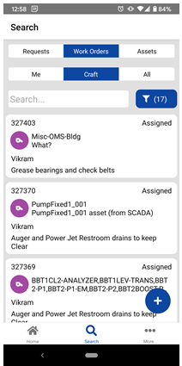

All Work Orders
- This list will open the search menu and prefill the object type to “Work Orders” and filter for all Work Orders.
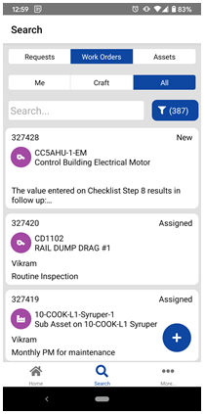

Down Assets
- This list will open the search menu and prefill the object type to “Assets” and filter for those Assets in a Down status.
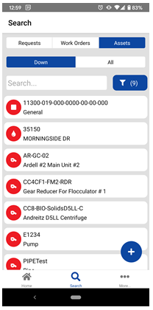

All Assets
- This list will open the search menu and prefill the object type to “Assets” and filter for all Work Orders.
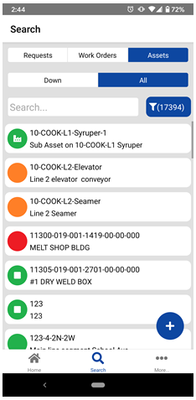

Search Screen
- The search screen will default to the last search that was run but the user can click to change the search object from Requests to Work Orders to Assets and filter based on “Me” (i.e. My Requests, My Work Orders only) or “Craft” (i.e. Craft’s Work Orders only) or “Down” (i.e. Down Assets only) or “All” records.
- Included is an additional set of filter fields that can be accessed by clicking the blue funnel button as shown below. The filter fields will change depending on what object is chosen (i.e. Requests, Work Orders, or Assets) and the filter fields will match the filters fields found in the core LLumin application.
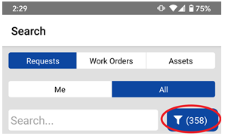

“More” Screen
- The More screen will include a button to open the core LLumin Application in a web browser, a button to log out of the mobile app, a button to initiate another sync without having to sign out and some details on the last sync date and how many changes are pending that are ready to be synced.
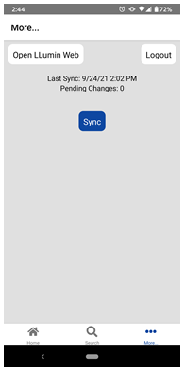

Requests

Create
- From within the Requests search, there is a plus button which will open the Request create screen as shown below. The blue plus button will not show unless the user has Work Request Create permissions. From this screen, a user can enter a Request Type, Priority, Craft, Work Requested, take a picture and link to the Request, and link an existing Asset (blue plus button under Assets) as shown in the example below.
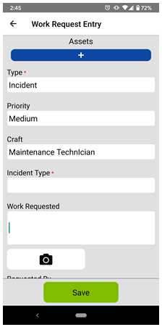

Edit
- Clicking on a Request in the search results will open the Edit Request screen that will contain the same fields as above with the exception of the ability to add a picture. The Work Request fields will be greyed out and un-editable unless the user has Work Request Edit permissions.
- The green Save button will only show when a field value has been changed.

Work Orders

Create
- From within the Work Orders search, there is a blue plus button which will open the Work Order create screen as shown below. The blue plus button will not show unless the user has Work Order Create permissions.
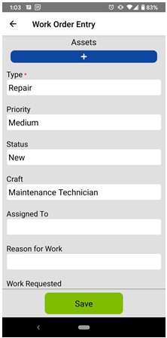

Edit
- Clicking on a Work Order in the search results will open the Edit Work Order screen that will contain the same fields as found within the LLumin core application. The Work Order fields will be greyed out and un-editable unless the user has Work Order Edit permissions.
- There are also tabs to enter information on the linked Procedures and Labor.
- The green Save button will only show when a field value has been changed.
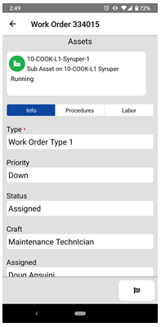

Complete
- Clicking the finish flag button in the lower right of the Work Order Edit screen will open the Work Order Complete screen as shown in the example below. The finish flag button will not show unless the user has Work Order Complete permissions. From within that screen, a user can choose to set the Date Completed to be “Now” or Labor End and set the status of the Asset.
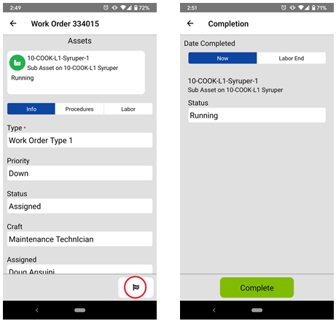

Labor Time

Existing Labor Time
- To review existing Labor Time on a Work Order, tapping on the Labor tab will display a list of existing Labor Time added to a Work Order as shown below and expose a blue plus button to add new Labor Time as covered in the next section.
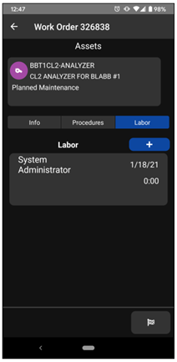

Adding new Labor Time
- Labor can be added from the Work Order edit screen by tapping on the Labor tab and clicking on the blue plus button as shown below.
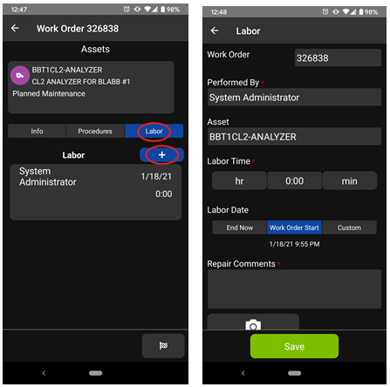

- By tapping on the hr and min buttons, Labor Hours/Minutes can be added as shown below. Labor Time is required.
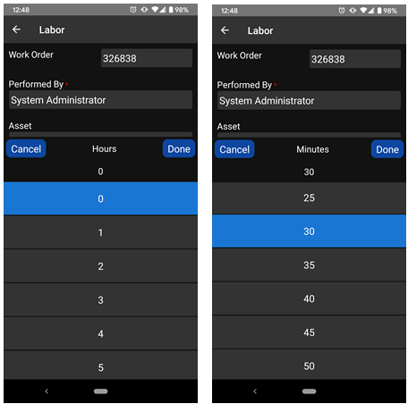

- By tapping on the textbox below the Repair Comments section, a keyboard will come up depending on your device to allow a user to enter comments as needed. Repair Comments are required to enter a Labor Time entry.
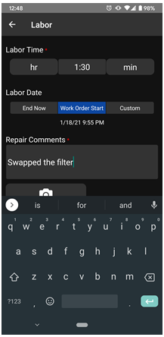

Copying Labor Time
- A user can copy from an existing Labor Time entry to create a new Labor Time entry by tapping on the existing Labor Time and in the lower right, tapping on the copy button. Tapping on the copy button will open a new Labor Time entry with the same WO #, Performed By, Asset, Labor Time, and Repair Comments.
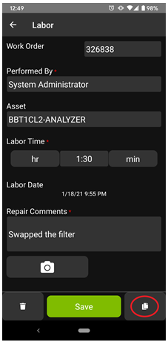

Assets

Create
- From within the search screen focused on Assets, click the blue plus button will open the Asset create screen as highlighted below. The blue plus button will not show unless the user has Asset Create permissions.
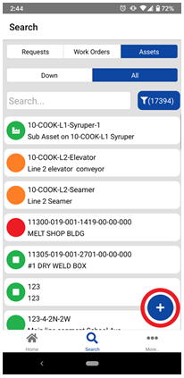
- The fields available on the Asset create screen will mirror those found within the LLumin core application and the same validation will occur upon sync of that Asset creation. Clicking the green Save button will complete the creation of the Asset but will not sync the new Asset until the sync is completed on the device.
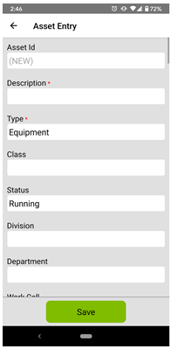

Edit
- Clicking on an Asset in the search results list will open the details screen of the Asset, exposing the fields on the Asset. The fields will be greyed out and un-editable unless the user has Asset Edit permissions.
- The green Save button will save the changes to the device but those changes will not affect the Asset in the core LLumin application until the device is synced.
- There is also a white wrench button to create a Work Order linked to the Asset that is currently open for edit as shown in the example below. This button will only show if the user has Work Order Create permissions.
