Our new Item Master Screen
Welcome to the updated Item Master Screen! In Version 24.5, we’ve made some big changes to improve your experience and streamline your workflow.
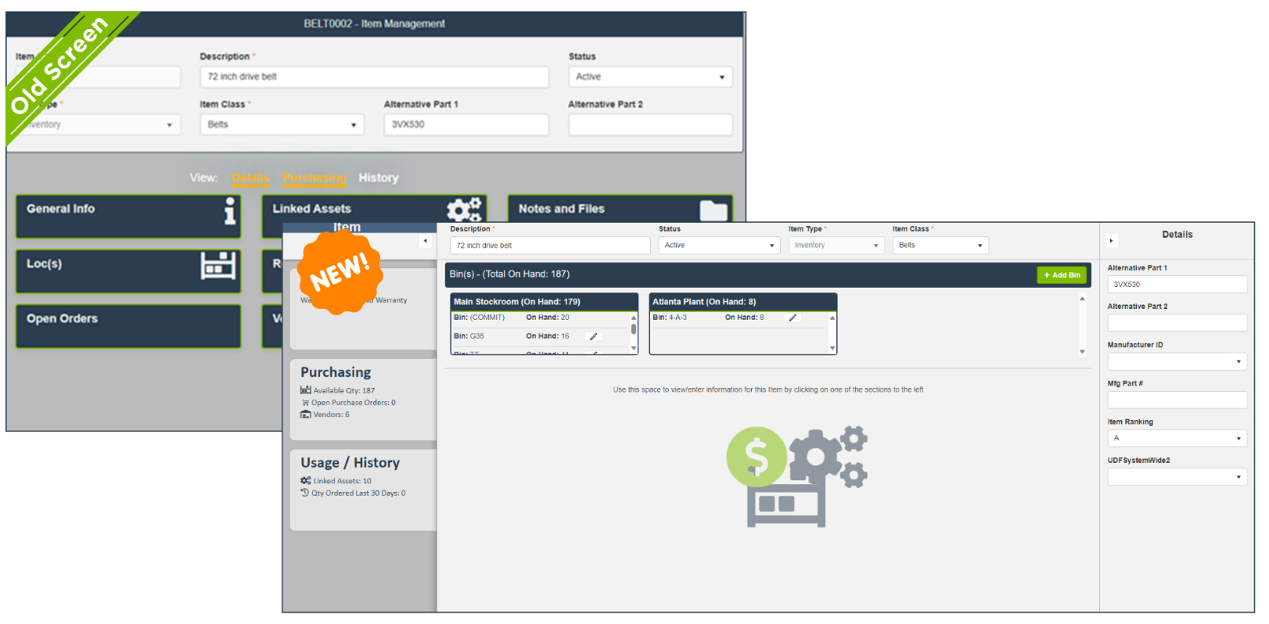
Why the redesign?
In response to valuable customer feedback, we’ve redesigned the Item Master Screen to reduce the number of clicks required to access information and perform actions. Our goal is to make data fields not only easier to find but also accessible within a single click.
Consistency and training benefits
This update is part of our ongoing effort to align the Item Master Screen with the Work Order Master and Asset Master screens. By ensuring consistency across the application, we minimize training needs and enhance ease of use.
What to expect
Below, you’ll find before and after images of the Item Master Screen. The new design introduces several user-friendly features that make navigating and managing item data more intuitive.

Before and After

Previous Item Master Screen
The original layout required multiple clicks to access detailed information, making the process cumbersome.
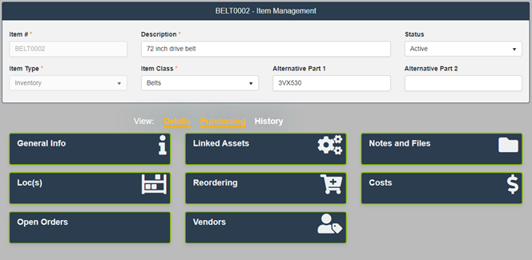

New & Improved Item Master Screen
The redesigned screen features at-a-glance information and easy access to details, reducing the need for multiple clicks.
Upper Screen Area
We’ve redesigned the upper part of the screen to display information that users most frequently referenced. This change allows users to quickly access data without navigating through multiple layers.
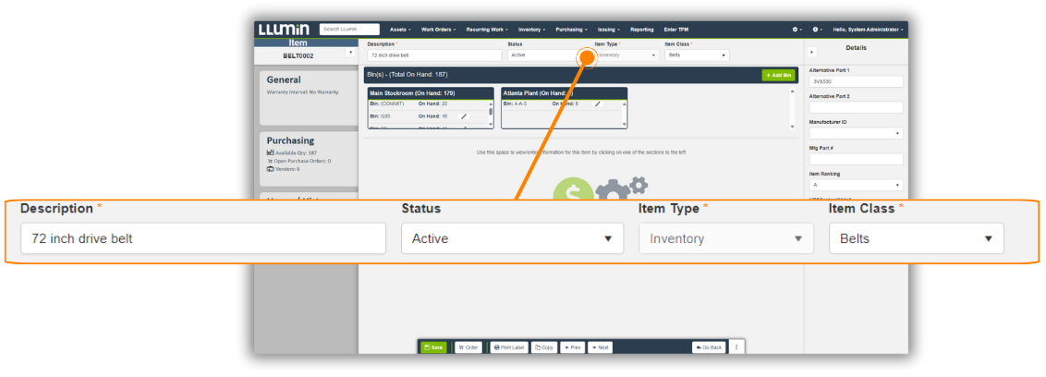
Details Section
The right side of the screen, known as the Details section, now presents important data such as alternative parts or Manufacturer ID without data without additional clicks.
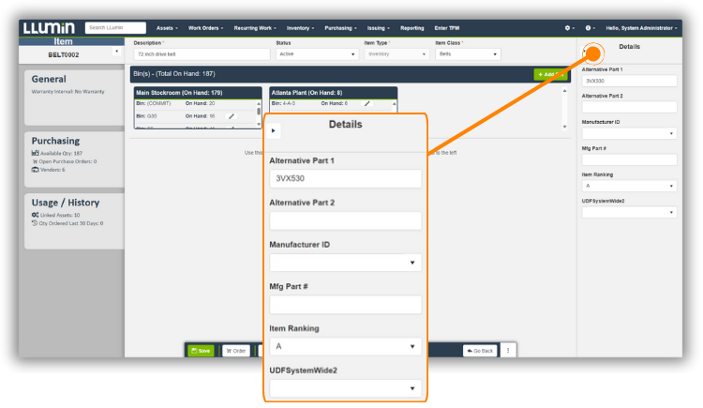
Tabbing Organization
On the left-hand side, we’ve organized information into three tabs: General, Purchasing, and Usage/History. These tabs are designed to segment information into manageable sections, reducing clutter and improving navigation.
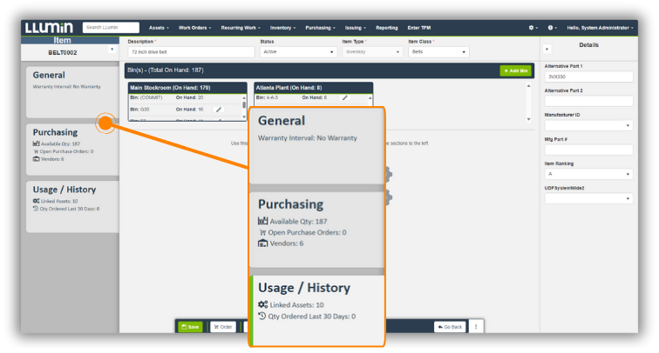
Actionable Data
Each tab now displays actionable data at-a-glance. Users can easily switch between the tabs with a single click, improving the interaction with the system.
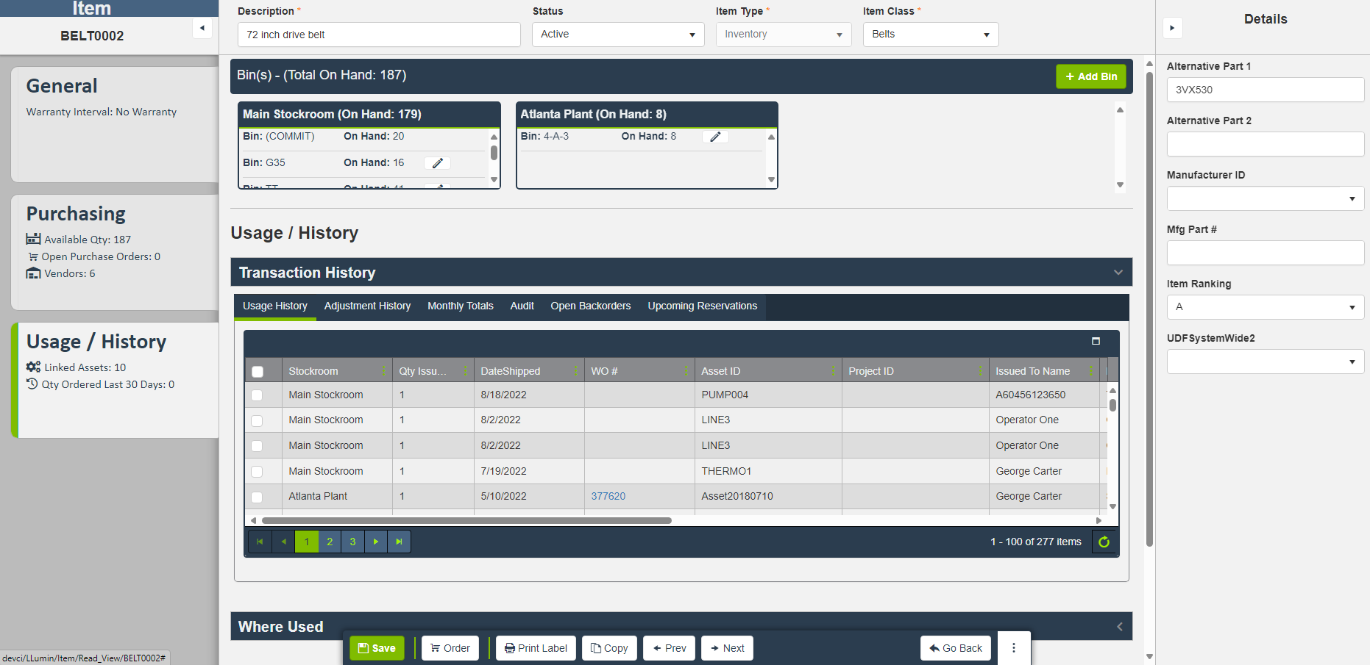

Explore the enhanced layout of the Item Master Screen, designed to streamline your navigation and improve accessibility to key functions

General Tab
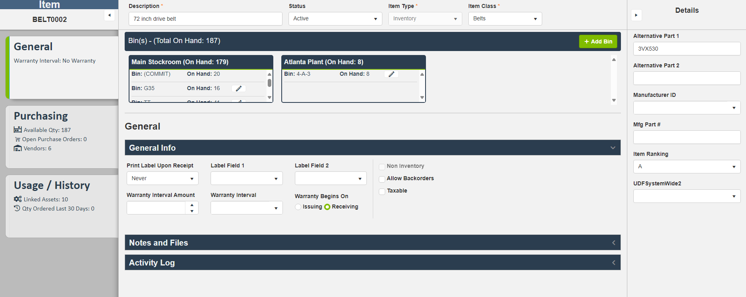
- Item Stockrooms/Locations: Overview of stock locations.
- General Info: Basic item information.
- Notes and Files: Section for additional notes and attached files.
- Activity Log: Log of activities related to the item.

Purchasing Tab
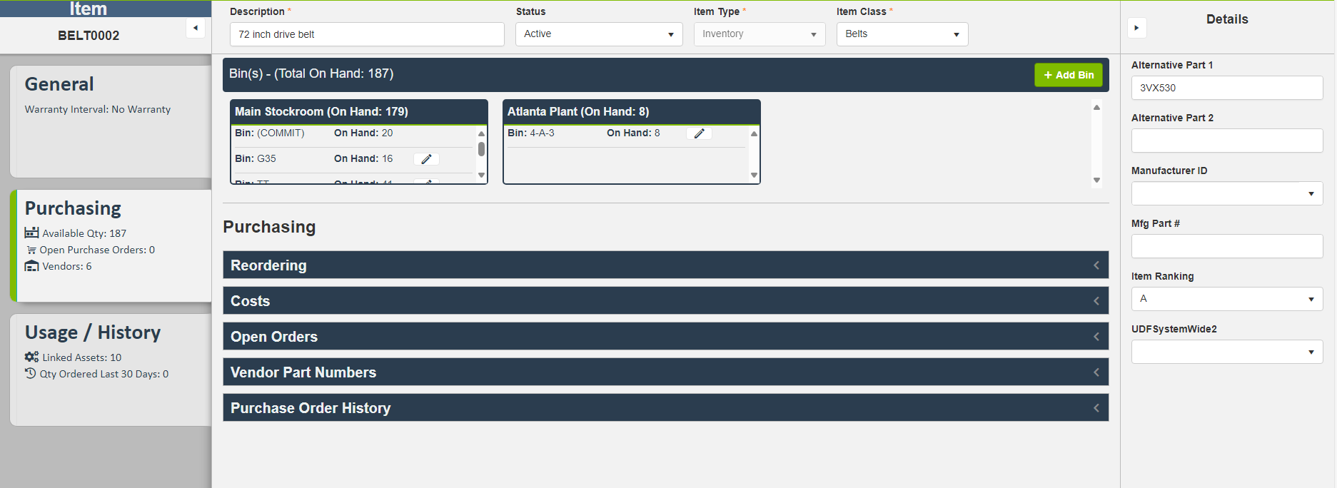
- Reordering: Details on reordering procedures.
- Costs: Cost information for items.
- Open orders: List of open purchase orders.
- Vendor Part Numbers: Information on vendor-specific part numbers.
- Purchase Order History: History of purchase orders.

Usage/History Tab
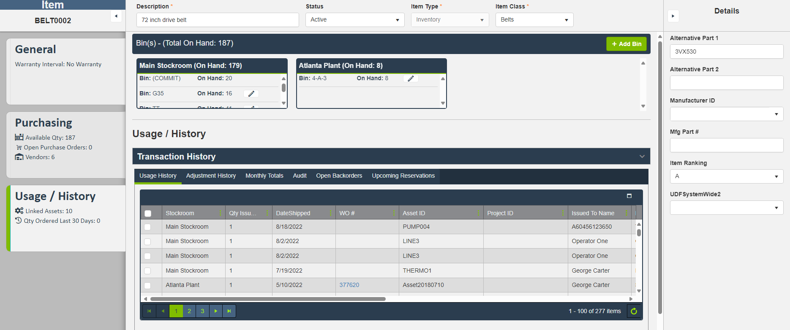
- Transaction History: History of transactions involving the item.
- Where Used: Information on where the item is used within the organization.
  - Linked Kits: Kits that include the item.
  - Linked Assets: Assets linked to the item.
Improved Navigation
The screen now loads with the Item Structure prominently displayed, followed by the General Info organized below with clear labels. This improvement ensures that users see the most important information first, reducing load times and enhancing the responsiveness of the application.

Enhancing user experience
Each improvement has been carefully designed to make managing items faster, easier, and more intuitive, reflecting our commitment to enhancing user satisfaction and operational efficiency.
For additional resources, updates, and support, please visit our website or contact our helpdesk at support@llumin.zendesk.com. We are committed to ensuring your success with LLumin CMMS+.

