Child Asset Selection When Moving Parent Assets
We are excited to introduce a new feature that enhances flexibility and control over asset management within our system. This guide will walk you through the new functionality that allows you to selectively include or exclude child assets when relocating a parent asset within the organizational structure.
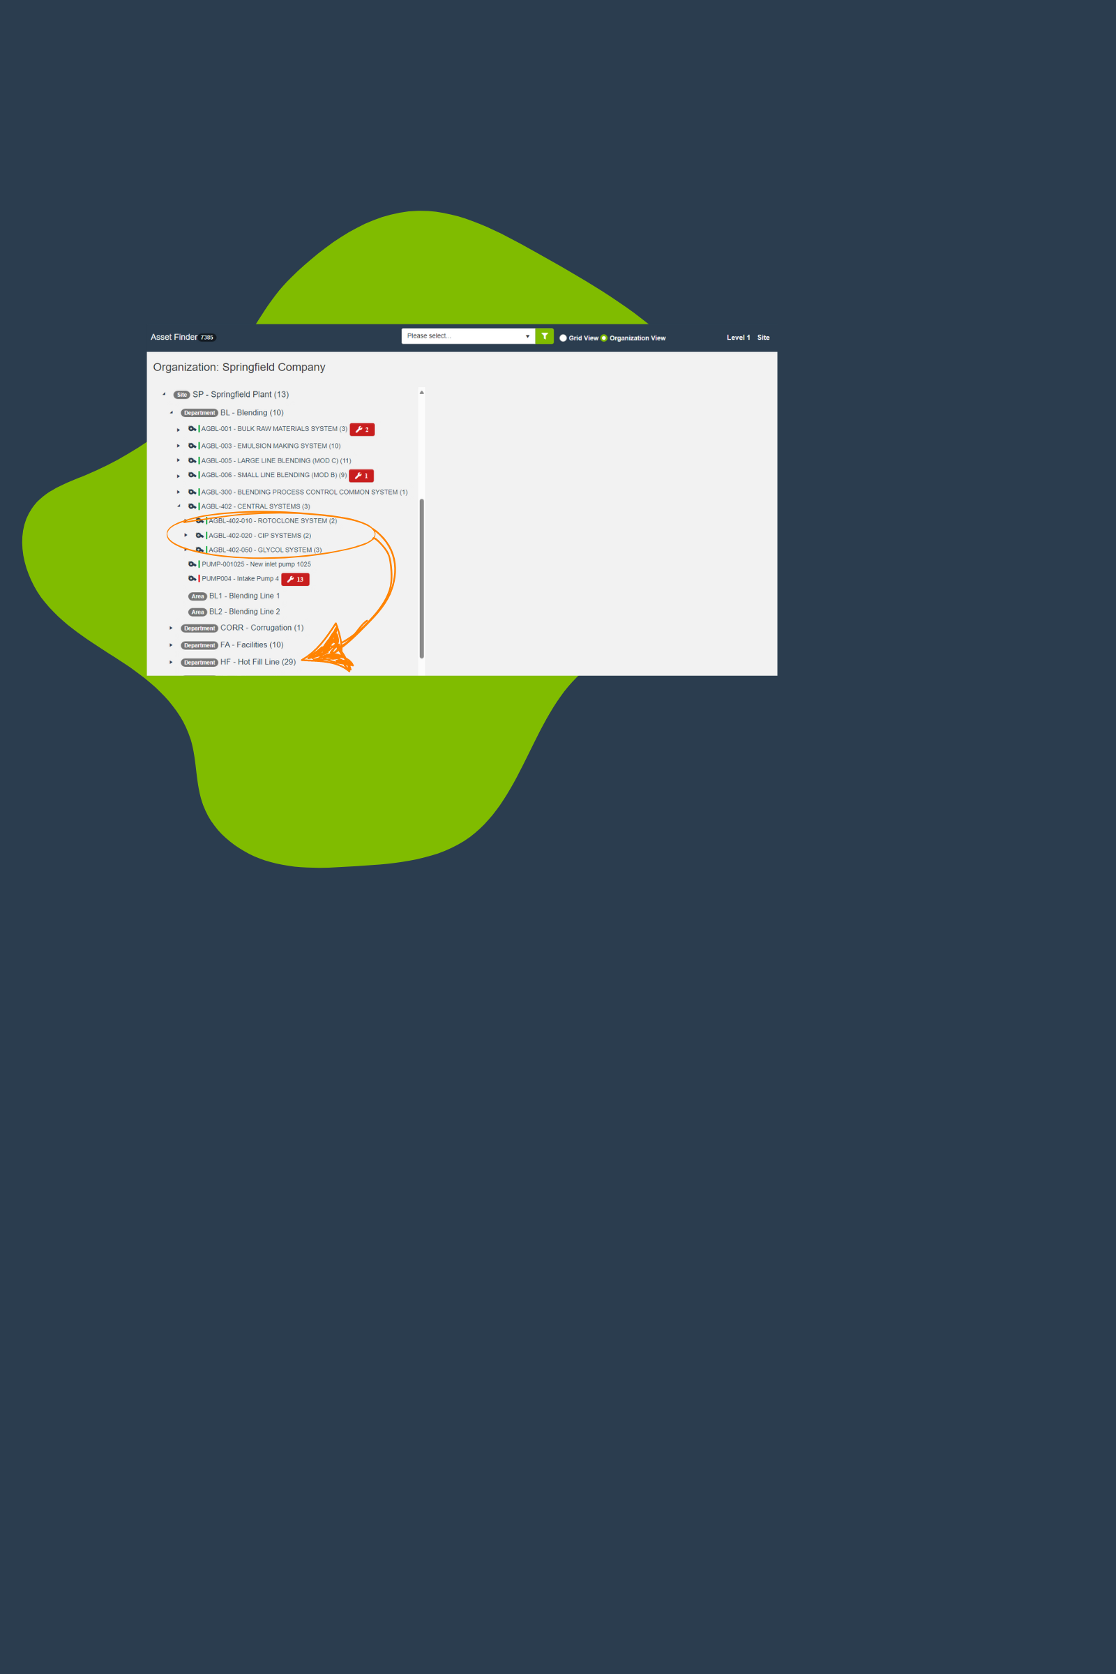

Why this feature?
This new feature gives you more control over asset management by allowing you to selectively move child assets with a parent asset. This is crucial in operations where different sub-assets may not always need to relocate together, allowing for tailored asset configuration at various locations or projects.
- Example: Consider a production line conveyor system in a manufacturing plant with attachable components like a barcode scanner and a packaging unit. If the conveyor needs to be moved to a new facility, you can choose to transfer only the packaging unit with it.

What’s new?
Our latest update aims to provide users with the ability to exclude some or all child assets during the movement of a parent asset to a new division, department, work cell, or parent-asset, ensuring greater adaptability to organizational changes.
Key features:
- Drag and drop: Easily relocate a parent asset within your organizational hierarchy.
- View: View linked child assets immediately after moving the parent asset.
- Customize: Pre-select which child assets will move, with the option to deselect any that should stay behind.
- Confirm: Securely confirm your selections with a simple click.
- Review: Review a detailed summary that clearly shows all moved assets.

How it works:
Take control of asset management with precision and ease using our new child asset selection functionality.
Here’s how you can manage the relocation of assets like INVERTER41, which includes child assets COMBINER11 and COMBINER12:
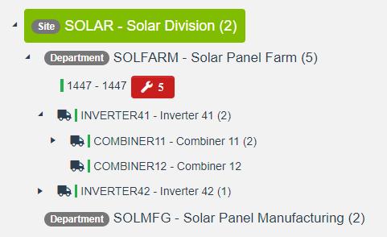
- Click on INVERTER41 and drag it into the Solar Panel Manufacturing department.
- As you place INVERTER41, the Move Asset interface automatically appears, clearly displaying all linked child assets.
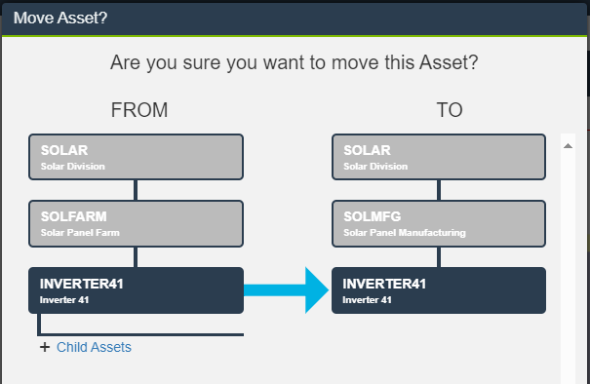
- Click on Child Assets next the + symbol at the bottom right to expand the section.
- View checkboxes next to each child asset. Pre-selected checkboxes indicate which assets are set to move with the parent.

- Verify the boxes for COMBINER11 and COMBINER12 are checked if you want them to move along with INVERTER41
- Click Yes to confirm your selections and implement the changes. Any child assets not selected will stay at their current organizational level but will be delinked from INVERTER41.
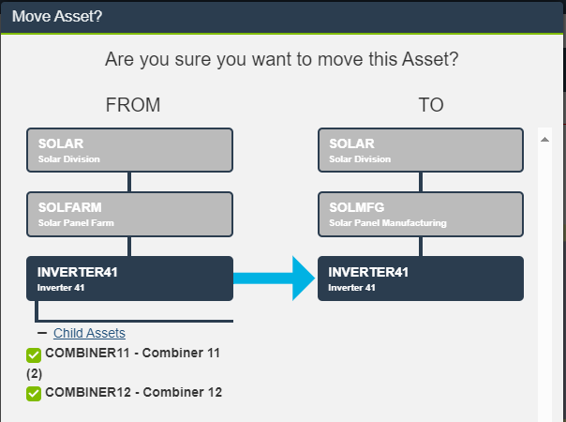
This feature enhances your ability to adapt asset management to specific operational needs, ensuring more efficient reorganization and maintenance of asset hierarchies.

Setup and configuration:
This feature is ready from the start! The child asset selection functionality is fully integrated and immediately available. No setup or configuration is required — start using this feature right away to manage your assets effectively.

Frequently Asked Questions (FAQs)
- Can I re-link child assets to a different parent after they have been delinked?
  - Yes absolutely. If you open the Child Asset record, you can specify a new Parent Asset as needed.
- What happens if I move a parent asset without selecting any child assets?
  - By default, when you move a Parent Asset, all children will be selected so if a user deselects all children, then all Child Assets will be delinked.

For additional resources, updates, and support, please visit our website or contact our helpdesk at support@llumin.zendesk.com. We are committed to ensuring your success with LLumin CMMS+.

