Multi-Currency Support
We are thrilled to introduce multi-currency support, a new feature designed to enhance the usability of our application for customers that purchase and receive in multiple countries. This functionality allows you to manage multiple currencies and their exchange rates seamlessly, ensuring accurate financial transactions worldwide.
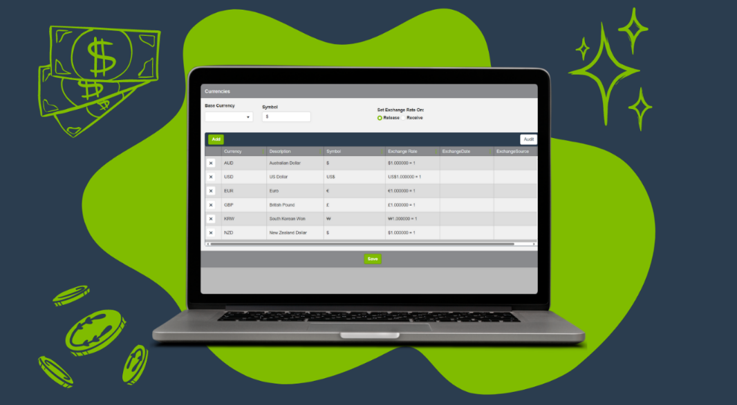

Why this feature?
Multi-currency support facilitates smooth financial operations across different countries by allowing businesses to handle transactions in the native currencies of their international suppliers and customers.
- Example: Consider a manufacturing firm that imports specialty components from several countries. With multi-currency support, the firm can directly process payments in each supplier’s currency and apply an on-hand valuation of items in the currency of the receiving location. This simplifies the payment process, enhances financial clarity, and minimizes the impact of exchange rate fluctuations on costs.

What’s new?
Key features:
- Multiple currencies: Manage several currencies with the ability to set a base currency and additional currencies, each linked to a defined exchange rate.
- Exchange rate control: Maintain control over exchange rates with options to set and update rates as market conditions change.
- Historical accuracy: Ensure financial accuracy by locking exchange rates at the time of transaction entries, preserving historical data integrity.
- Vendor-Specific settings: Automate currency selection on transactions based on vendor-specific default currencies.

How it works:
Open our application and start managing transactions across various currencies.
Navigate to the feature:
- To access the new feature, go to Configuration Mode > Materials Management > Currencies.
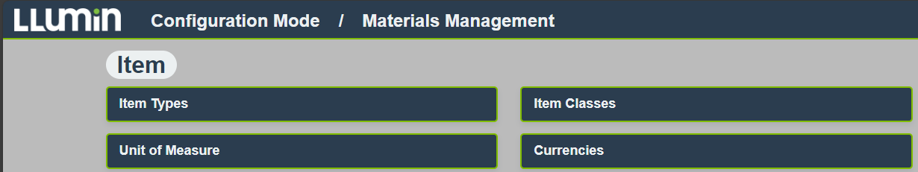
Add and manage currencies:
- Add a currency: Click Add to include a new currency to your system. Select from a comprehensive list of global currencies as needed for your operations.
- Set exchange rates: Specify the exchange rate in relation to your base currency. The setup for managing exchange rates is covered below in the Setup and Configuration section.
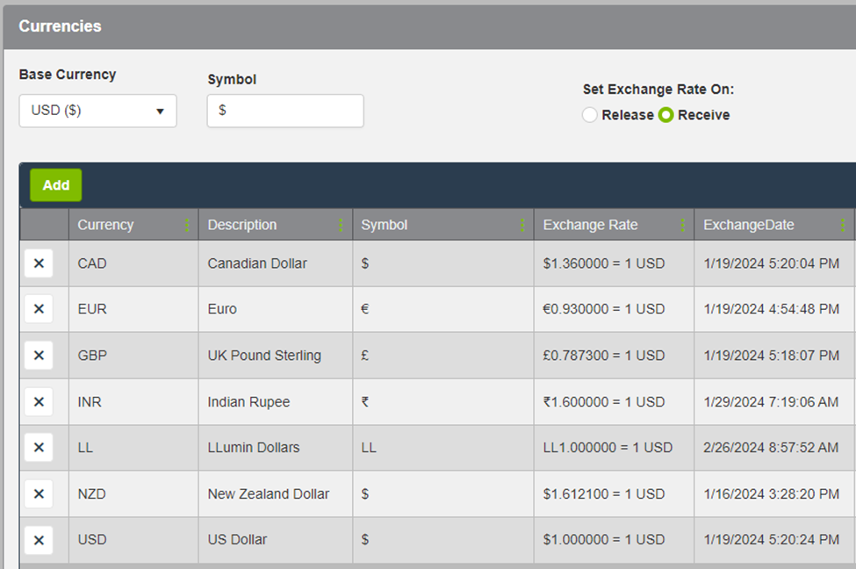

Vendor-specific settings:
- If you navigate to a vendor’s record, you can set the default currency for all transactions with that vender. This ensures consistency and accuracy in financial dealing, streamlining financial processes.
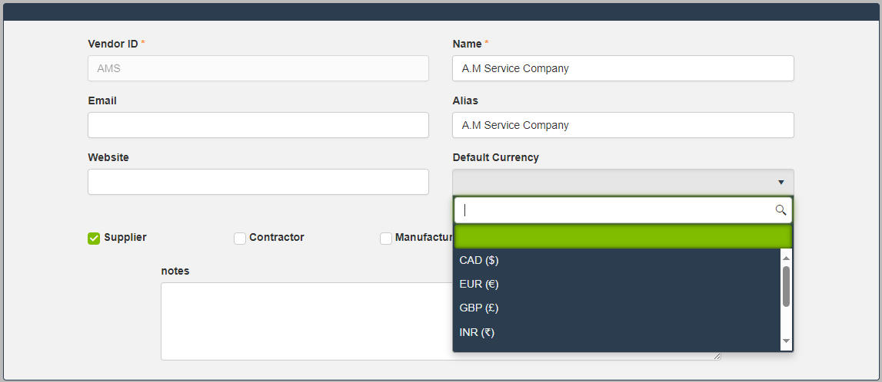

Setup and configuration:
Ready to optimize your financial operations? To ensure you get the most out of this feature, we invite you to connect with us to explore how exchange rates are updated within our system. Available options include:
- Manual updates for hands-on control.
- API integration to automate updates and ensure seamless data flow.
- Integration with your existing financial services or databases for consistent fiscal management across all platforms.
And more!
To explore these possibilities and activate the feature according to your requirements, please contact our support team. We are ready to assist you in activating and configuring the currency exchange rate functionality to meet your needs.

Frequently Asked Questions (FAQs)
- How often should I update the exchange rates in the system?
  - While the frequency of updating exchange rates is flexible to accommodate different business needs, we recommend updating this information once a day.
- Can I automate the update of currency exchange rates using an API?
  - Yes, you can automate the update of currency exchange rates through our API. This feature allows you to integrate real-time financial data services or your preferred currency exchange rate provider to ensure your system always reflects the most current rates. Contact our support team to get started!
- What if I do not update the exchange rate and process a PO with an out-of-date rate?
  - You can unreceive and then cancel the PO, update the exchange rate, and recreate the PO using the new rate.
- Is there a limit to the number of currencies I can add?
  - No, there is no limit currently but as the number of currencies increases, the maintenance of the rates will require more work.

For additional resources, updates, and support, please visit our website or contact our helpdesk at support@llumin.zendesk.com. We are committed to ensuring your success with LLumin CMMS+.

