Sub-Statuses for Serialized Items
We’re excited to roll out our new sub-status functionality for serialized items, crafted to refine the precision of status management across serial numbers within our application. This feature elevates your ability to gain deeper insights and exert greater control, enhancing your inventory tracking capabilities.
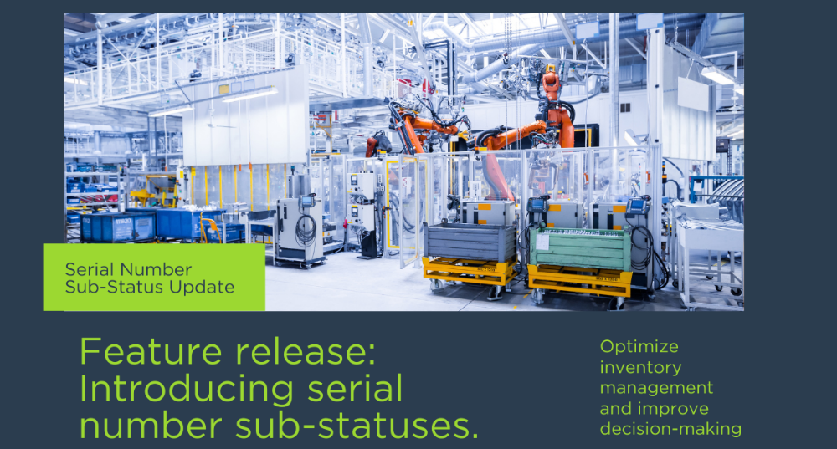

Why this feature?
Sub-statuses introduce a layer of granularity that transforms inventory management. By providing specific details about the condition or usage stage of inventory items, these insights allow your business to streamline operations and fortify decision-making processes.
- Example: Imagine a manufacturing plant where critical machinery such as pumps or generators are essential. Sub-statuses like “Under Maintenance” or “Needs Inspection” enable your maintenance teams to swiftly pinpoint which equipment requires immediate attention, significantly reducing downtime and boosting overall production efficiency.

What’s new?
Key features:
- Flexible sub-status setup: Easily configure and manage sub-statuses to reflect various item conditions within your inventory.
- Dynamic status linking: Sub-statuses automatically link to main statuses, simplifying data entry and consistency.
- Efficient management tools: Add, edit, or remove sub-statuses directly within Configuration Mode to keep your inventory statuses up to date.

How it works:
Open our application and start utilizing the new sub-status functionality to refine and elevate your inventory management.
Navigate to the feature:
- Begin by navigating to Configuration Mode > Materials Management > Serialized Item Statuses.
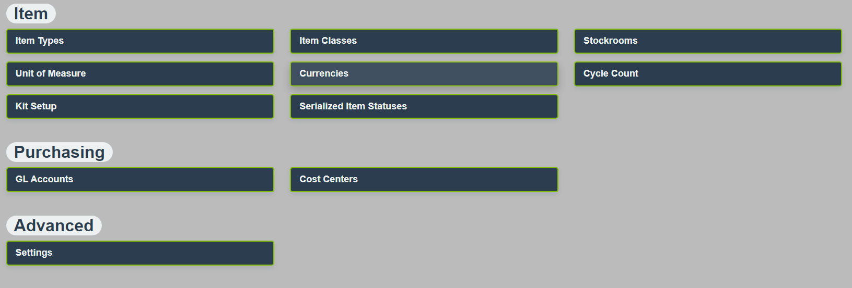
Actions you can perform:
- You can click the plus icon to add new sub-statuses.
- Make modifications to existing sub-statuses by clicking the pencil icon.
- Remove outdated or unnecessary sub-statuses using the trashcan icon.
- Establish default sub-statuses for various statuses to facilitate quicker and more consistent entries.
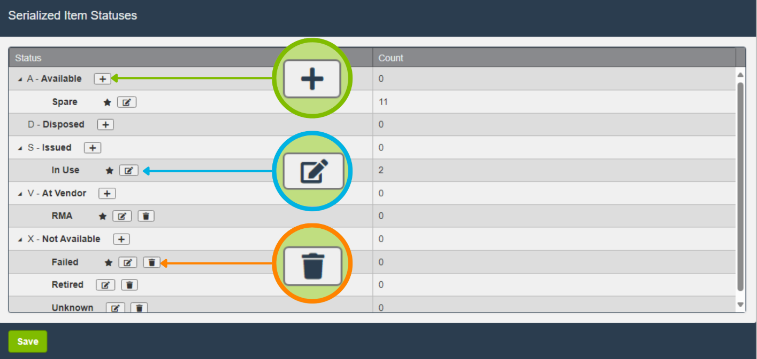
In the screenshot below, observe how sub-statuses like ‘Spare’ and ‘Retired’ are paired with their respective general statuses AVAILABLE and DISPOSED.
This intuitive pairing simplifies the selection process, ensuring that the correct status is automatically applied when a sub-status is chosen.
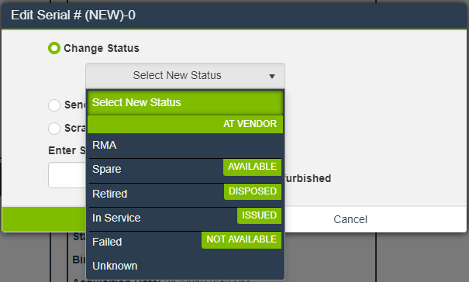

Setup and configuration:
Want to enhance your inventory management today? To fully leverage the capabilities of the sub-statuses in our system, we invite you to ensure your initial setup is complete. Follow these steps to activate and optimize your setup.
- Verify Initial set-up:
  - Navigate to Configuration Mode > Materials Management > Settings.
  - Use the search bar to find “Show Serial Status.”
  - If not already active, toggle the feature ON.
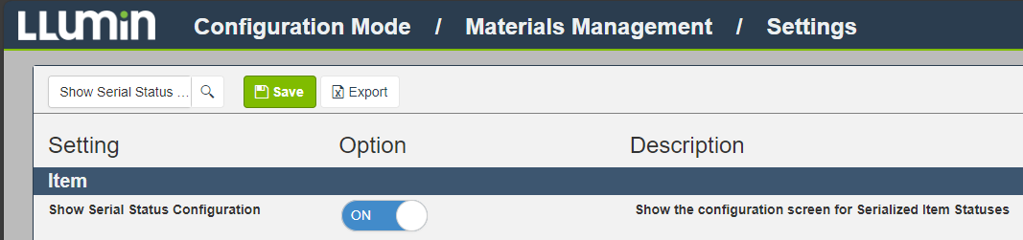
- Activate Sub-Statuses:
  - Once the serial status setting is confirmed and activated, you automatically gain access to use sub-statuses. There are no additional setup requirements. You’re ready to go!

Frequently Asked Questions (FAQs)
- What is a sub-status, and how is it different from a status?
  - A sub-status provides additional detail about an item’s condition or usage phase within its main status category. For instance, if an item’s status is “Available,” a sub-status could further specify whether it’s “In Use” or “Reserved,” offering more precise tracking information.

For additional resources, updates, and support, please visit our website or contact our helpdesk at support@llumin.zendesk.com. We are committed to ensuring your success with LLumin CMMS+.

