LLumin February 2020 Feature Release Notes

Modules

Excel Import Template

We have created an Import Template file built in Microsoft Excel that contains validation on each field to ensure any data entered is in the proper format to be imported into the LLumin application. This Import Template will allow system administrators to import data for Assets, Procedures, Recurring Tasks, Inventory, and/or Vendors. Please refer to the User Guide on the LLumin Support Portal for more information.

Workflow module

We have made significant improvements to the Workflow module in terms of overall processing, the interface around creating or editing Workflows and the notifications that come out of Workflows.

Some highlights include:

- Conditions and Condition Groups
  - There is now a single area where the workflow conditions will be set up, rather than having a list of conditions and dragging them into Condition Groups, the conditions will automatically be set up within a group and can be dragged between groups.
    - When the desired condition is dropped into a new group a dialog will appear asking the user if they want to move the dragged condition or copy it into the group.
  - We have added the ability to collapse the Condition Groups which gives the user even more room to read through the rule logic, the Condition Group will turn into a card that displays the text of the contained rules, separated by commas when collapsed.
  - We have added the ability to set the name of Condition Groups to something other than what is automatically generated from the condition descriptions.
  - We have added the ability for the user to set a duration for each Condition Group that will monitor how long that condition should exist before triggering the workflow rule.
- Workflow Notifications
  - Notifications are now three levels deep rather than two.
    - There are notifications and notifications contain Escalations and Escalations contain Escalation Groups. The Escalation Groups are the groups of users that will be alerted when the workflow rule triggers.
    - Notifications
      - By default, each notification will be monitored 24/7. On the top of the notification it will say ‘Restrict Notifications to a specific time’, if the user clicks this it will bring up a dialog allowing the user to select a schedule that is currently in the system or they can edit/create a new schedule. Also, by default the option to attach the printed report within the notification message will be turned off and the notification message will be empty. If the user wants to attach the printed report, they can click the printer icon on the top of the notification, and this will turn it on. If the user wants to set the notification message to a custom message, then they can click the message icon on top of the notification. This will bring up a dialog that will allow the user to enter the custom message.
    - Escalations
      - The Escalations right now are split into two types: approve and notify. When setting up a new Escalation the user is given two cards to choose from that represent the two Escalation types. When the user clicks on either of these cards it will bring up the dialog where the user must select the Escalation Group that will be notified. This dialog is similar to the schedules dialog as the user can edit/create a new group here. If a user chooses to require approval, they are also given the option of requiring a minimum number of users to approve the triggered workflow rule and adding a renotification interval. Users can also add other Escalations to the notification but when “escalating” to another Escalation the user must set the amount of time it will take before escalating. The only restriction being that if a group is already on the notification then it cannot be added again.
    - Escalation Groups
      - The Escalation Groups are simply a link between the Escalations and the groups. The only restriction for the Escalation Groups is that they must have at least one of the notification methods set when saving the workflow rule. A warning icon will be shown above the notification method if any of the users within that group do not have that notification method setup within their user profile.
- General Updates
  - We have added a toolbar to the Workflow creation screen to more closely resemble other screens for consistency
  - We have redesigned the Workflow Finder to more closely resemble other Finders for consistency
  - We will add a button to the toolbar that will bring up a log of the Workflow triggers and approvals/rejections in a popup window.
  - We have added the ability to create Workflow Rules based on Work Requests
  - We have added the ability to click on the name of a Workflow Rule and edit the name without opening the record
  - We have added User Security options for Workflow Rules
    - If the user has delete permissions then they can view all of the workflow rules. If they do not have delete permissions, then they will only be able to view the object types they are allowed to edit.
    - The ‘Create Rule’ and ‘Create Sequence’ buttons will only show if the user has the permission on that object type.
    - If the user doesn’t have any of the checkboxes set then they won’t be able to see the menu bar item for workflow rules.

Reporting module

We have made numerous improvements to the reporting module including dashboards, a more user-friendly folder structure and interface. LLumin will be offering multi-day reporting training in Springfield, MA this Spring, and more info will be forthcoming. Training will include report development as well as all new dashboarding.

Some highlights include:

- New Folder Structure

  - We have modified the folder structure to more closely mirror the application structure which includes READYAsset and READYTrak
    - The previous standard reports were broken out by groups based on purpose (Asset, Labor, etc.) but now they are all under one folder for LLumin Standard Reports and match the menu options more closely (READYAsset –> Labor, READYTrak –> Purchasing)
    - The previous “Forms” reports, the report used when printing Purchase Orders for example, have been moved to the “Integrated Forms – Default” folder and any customized versions of those “Forms” are now under “Integrated Forms – My Company’s Forms”
  - All the non-standard reports that were created have been moved to the folder “My Company’s Reports” so they will all now be in one location instead of multiple “Custom” folders
  - Reports added under the “Available for Home Page” folder in “My Company’s Reports” will make that report available in the Home Page Grids in User Management

Please see the below for a comparison of the previous (left) folder structure and the new (right) folder structure:

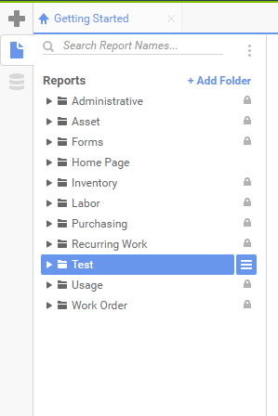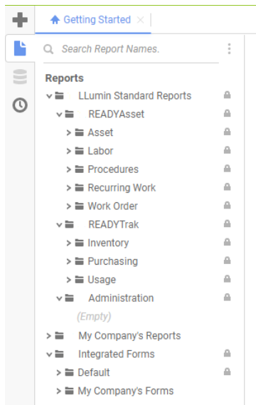
Improved User Interface
  - We have moved the new report functions to the main “Get Started” page
  - We have added more easily accessed Help contents and provided some tutorials on the reporting module
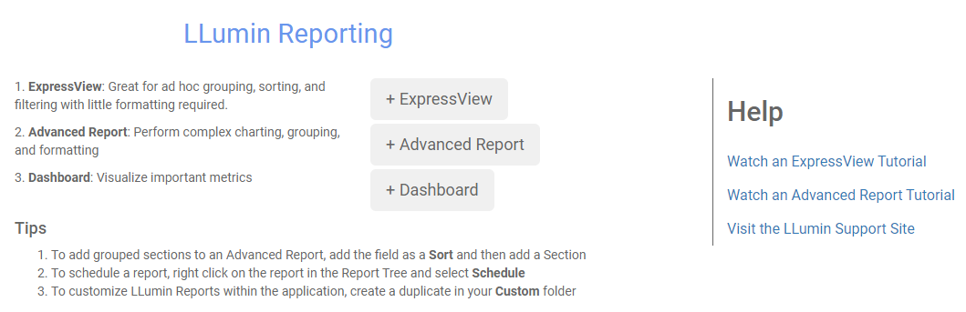

  - The Express View interface has been improved to be more user-friendly
    - Within the Express View reports, users now have the ability to filter and sort based on a formula they configure
    - Express View report filters in general have also changed. Previously when a filter value was left blank, the filter logic would find any records where that field has no value; one example would be a Usage report with a filter WO_Nbr is “___” would find all records with no WO_Nbr. In the new reports, if a filter value is left blank, the filter set will ignore that filter; using the same example, if a filter WO_Nbr is “___” then all records regardless of WO_Nbr value will be returned. If a filter truly should be finding those records where a field is blank, then there is a value (BLANK) at the top of every dropdown that should be used.
    - Visually, the interface is also more user-friendly, see the below example
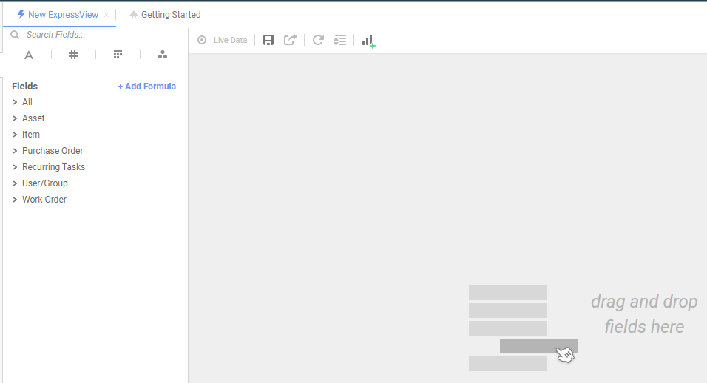

    - The ability to add filters, style, formulas, etc. has also been brought out of the cell details as shown in the example below
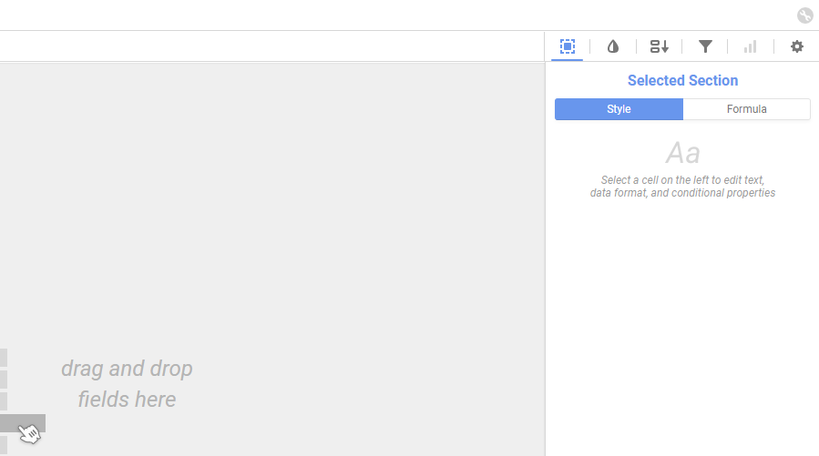

Here is a sample Inventory Master List report which illustrates some of the functionality outlined above:

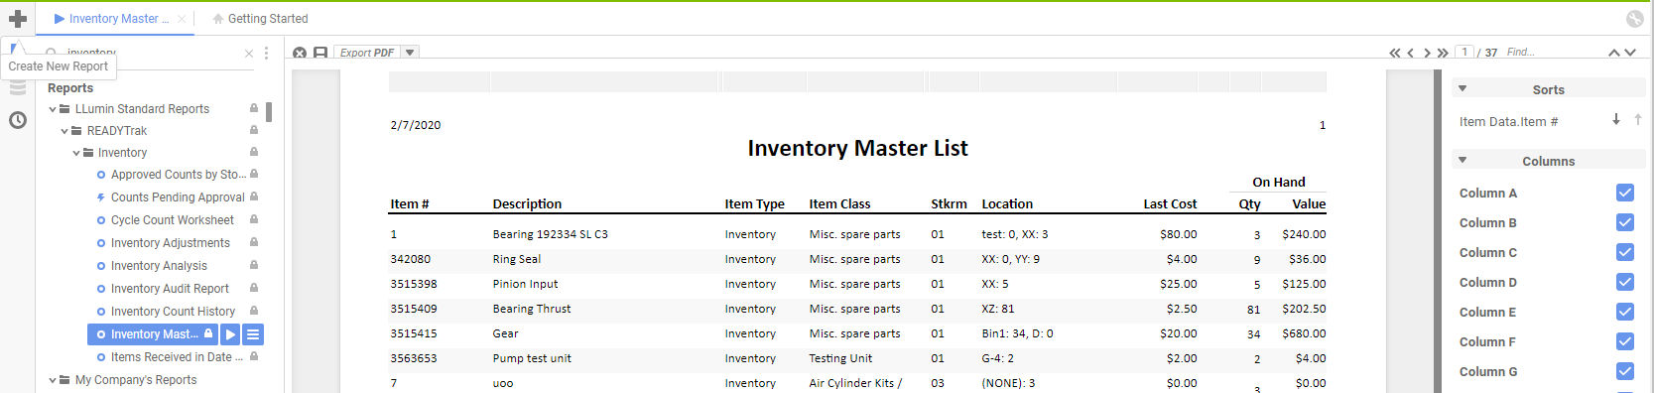

- Additional Details
  - While the report folders and overall look and feel may have changed the underlying logic and purpose behind the reports have not changed.
  - All previously created reports will still exist in the new folder structure
  - All previously created schedules will still exist and have not changed

