This document will cover installing a Label Printer in V5. This is only applicable for Zebra printers.

Contents
Contents 1
Part 1 – Installing and Configuring QZ Tray 2
You will need to download/install QZ Tray to manage the printer 2
After QZ Tray is installed, you will need to test and configure it for use 3
You will need to restart QZ Tray to implement the changes 7
Part 2 – Adding the printer to LLumin 8
Add the printer to the Llumin application 8

Skipping to a particular section is easy simply hold ‘Ctrl’ and left-click on the section in the contents table above

Part 1 – Installing and Configuring QZ Tray

You will need to download/install QZ Tray to manage the printer
- In the application go to System Setup under the gear icon in the upper right
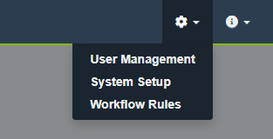

- Click Miscellaneous

- Scroll down to the Label Printer Settings section and click Get QZ Tray
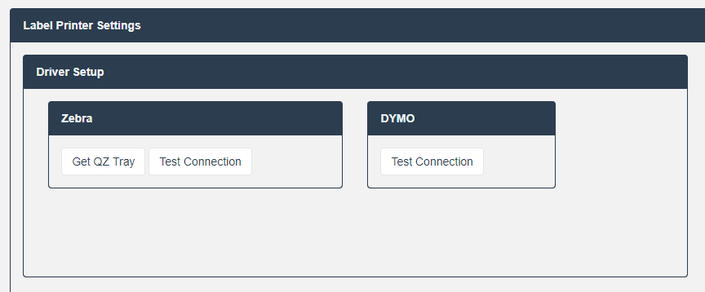
- This will bring you to the qz.io/download/ link where you can download the latest version of QZ Tray
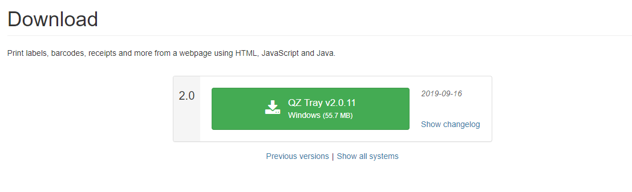
- Click the large green button with QZ Tray and the version
- Once the installer is downloaded, click it in the bottom of your browser or navigate to where you downloaded the file and double click to run
- Follow the steps in the install wizard
  - It will be easier to configure if the default installation directory is used
- Once QZ Tray is installed, a green cube will appear in your system tray 

After QZ Tray is installed, you will need to test and configure it for use
- In the application, back in the Label Printer Settings section of System Setup – Miscellaneous, click Test Connection
  - This will bring up the QZ tray application and it will prompt you to accept the untrusted website, click Allow
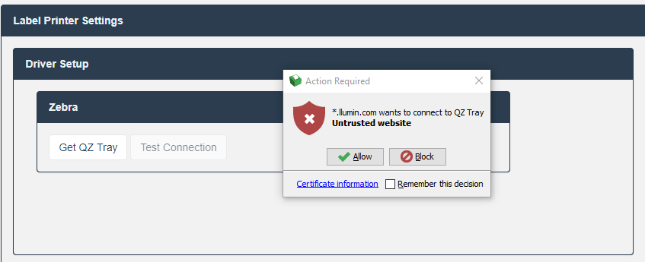
  - If the test was successful then the box will turn green as shown below and you can proceed in the steps. If not, please uninstall QZ tray and try to install again with the default values.
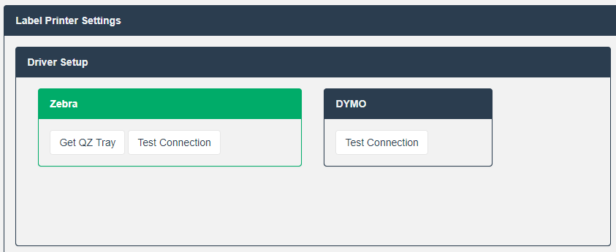
- To configure QZ Tray, right-click the QZ Tray icon in your system tray (it looks like a green cube) and click Advanced – Open file location. You may need to click the “up arrow” to show hidden icons.
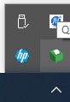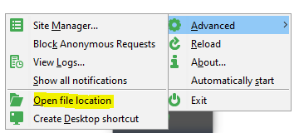
- In the window that is opened, there should be a override.crt file. If there is no such file, please reach out to support@llumin.zendesk.com to have one sent to you.
  - Please note you will need to be a local administrator on the computer in order to copy over the override.crt file.

- In the same location, there is a file called qz-tray.properties that will need to be edited.
  - To do so, click the Start Menu and type Notepad
  - Right-click on Notepad and click Run as Administrator
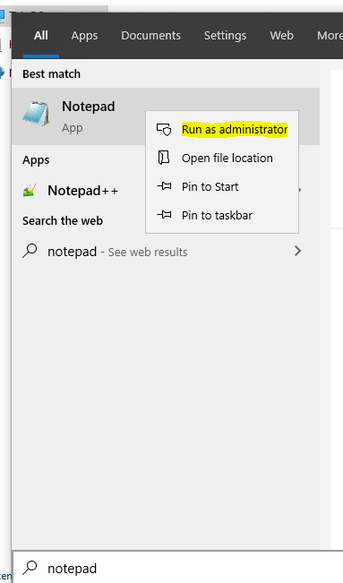
  - In the elevated session of Notepad, click File – Open
  - Navigate to C:\Program Files\QZ Tray if you used the default installation directory when installing QZ Tray or the specific directory specified.
  - Click the dropdown next to File Name to select All Files instead of Text Documents to get a full list of files
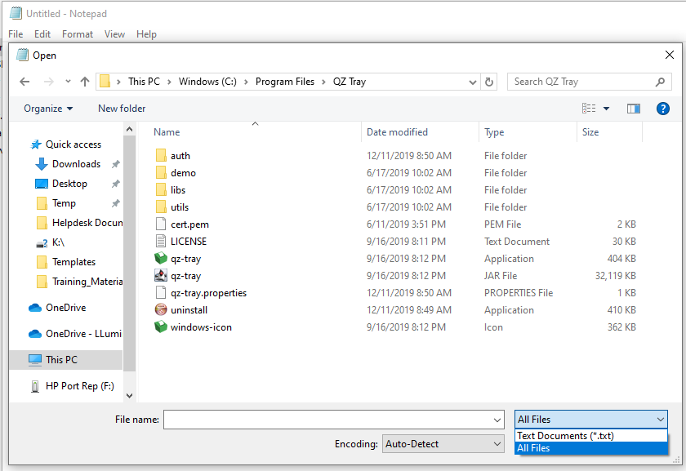
  - Double click the qz-tray.properties file to open it
  - At the bottom of the file, add a new line - C:\\Program Files\\QZ Tray\\override.crt
    - Please note the double slashes, this is done purposely
  - Click File – Save or type CTRL+S to save the file

You will need to restart QZ Tray to implement the changes
- To restart the QZ Tray service
  - Right-Click the QZ Tray icon in the system tray (looks like a green cube) and click Exit
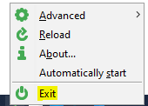
  - Once the icon disappears from the system tray, you will need to navigate back to C:\Program Files\QZ Trayand double click the qz-tray application file which looks like a green cube. This will start QZ Tray running.

Part 2 – Adding the printer to LLumin

Add the printer to the Llumin application
- To add the printer in the LLumin application
  - Under System Setup – Miscellaneous in the Label Printer Settings section, there is a sub section marked Add a Printer
  - Check the box next to Zebra, click Search… and from the Connected Printers dropdown, find the printer you have connected
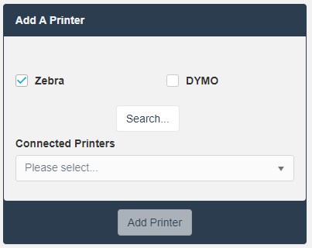
  - Click Add Printer
  - Under the Printer Settings, select the printer you have connected
    - Printer type should match your printer brand
    - Label Width and Height should match your label stock
    - Printer DPI can be found in the manual for your printer
    - Printer Description can be used to differentiate between multiple printers on the same computer
  - Under the Example Label section, select the layour of the label using Item, Location or Serialized Item.
  - Test Print to ensure the printer has been set up properly

